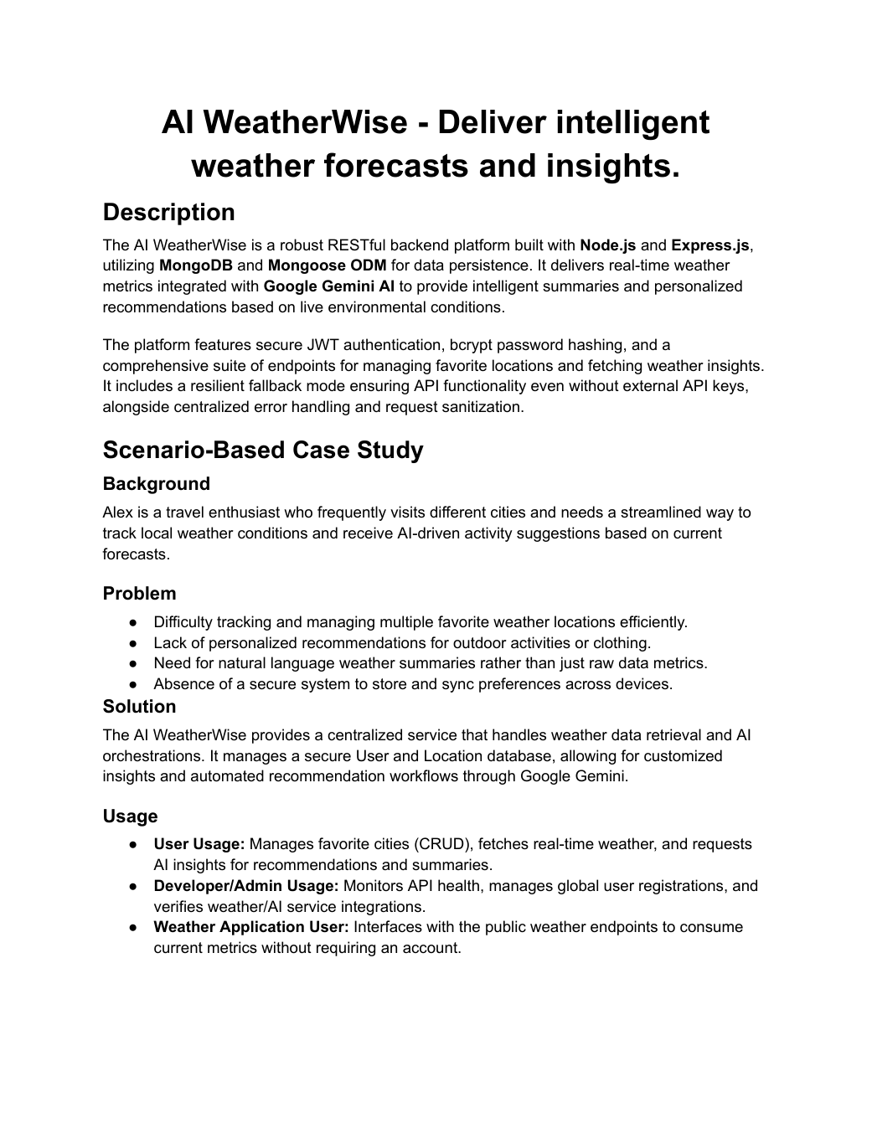

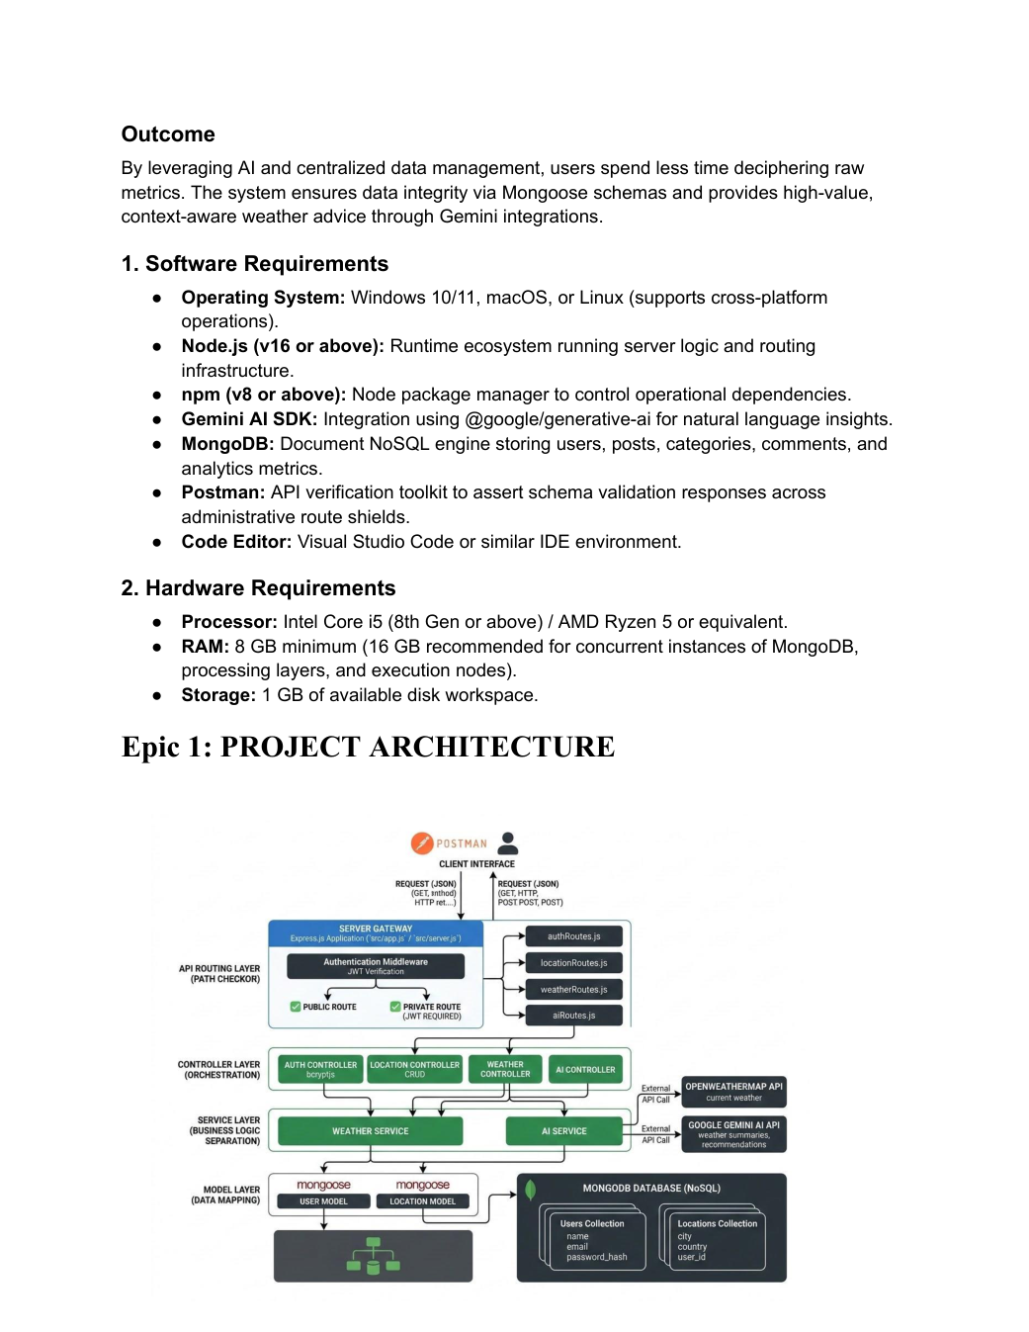

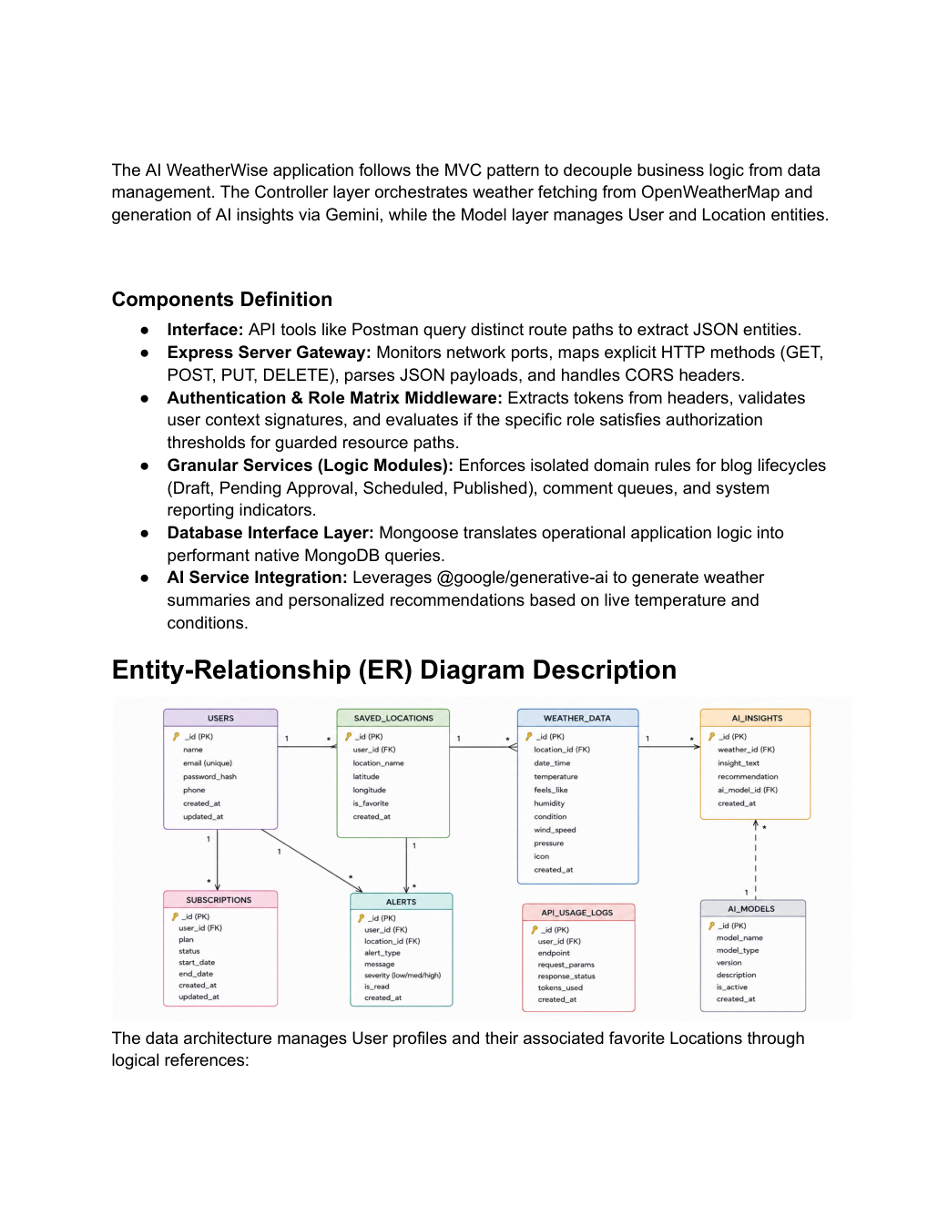

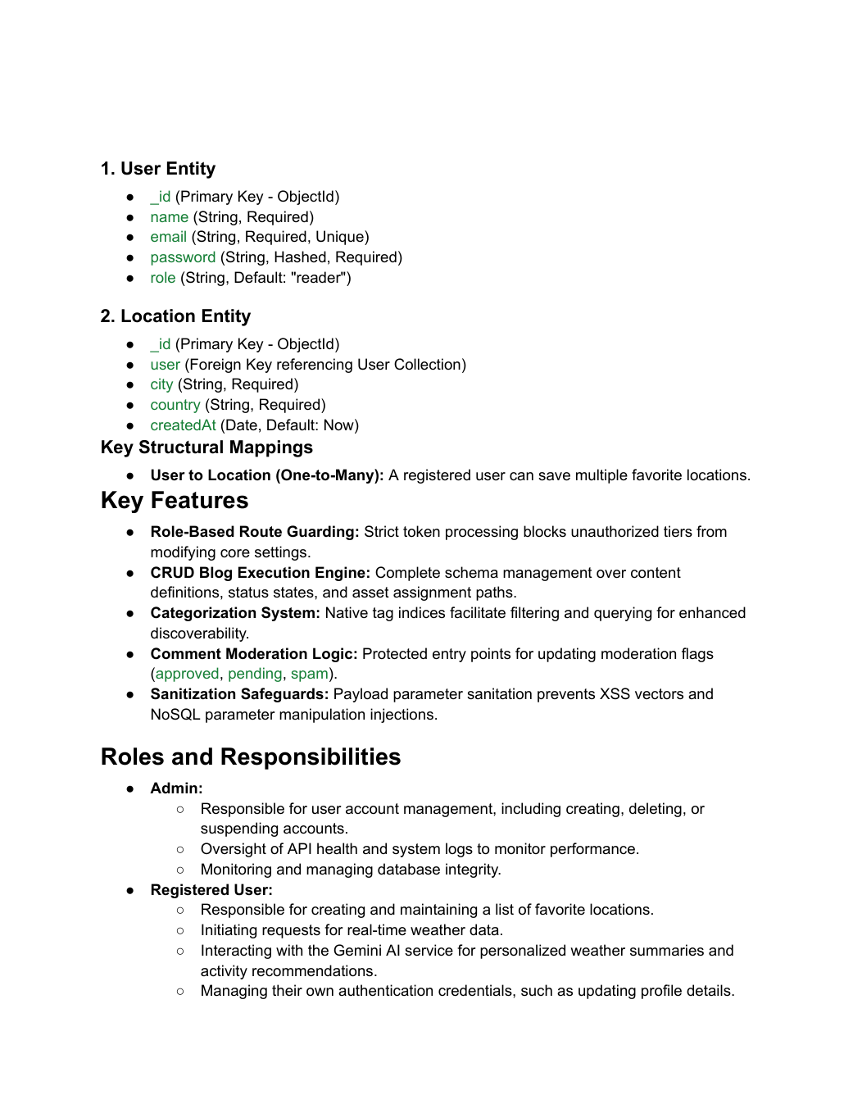

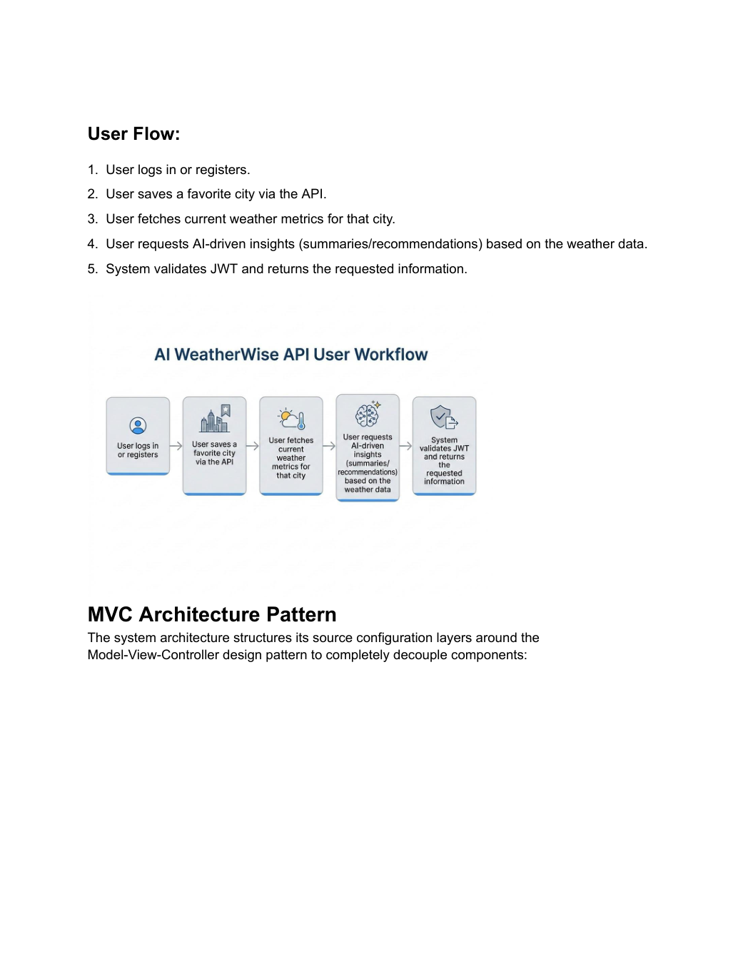

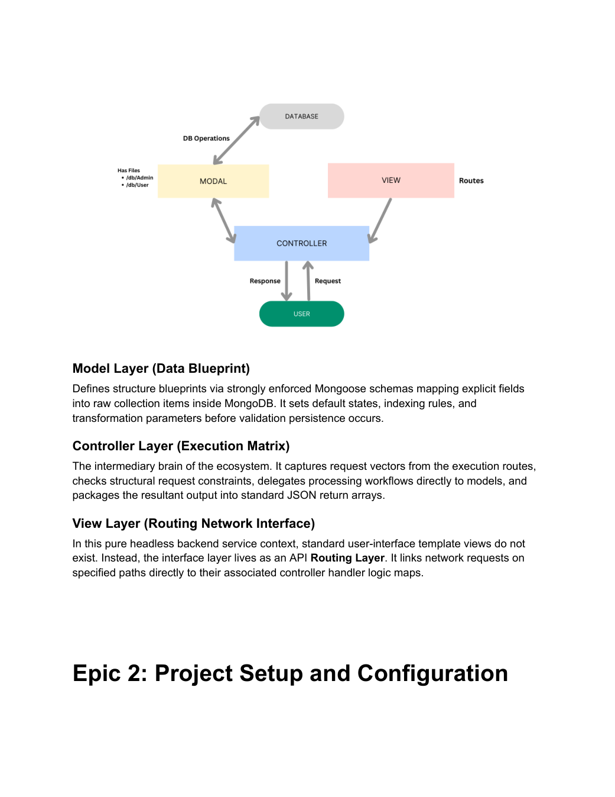

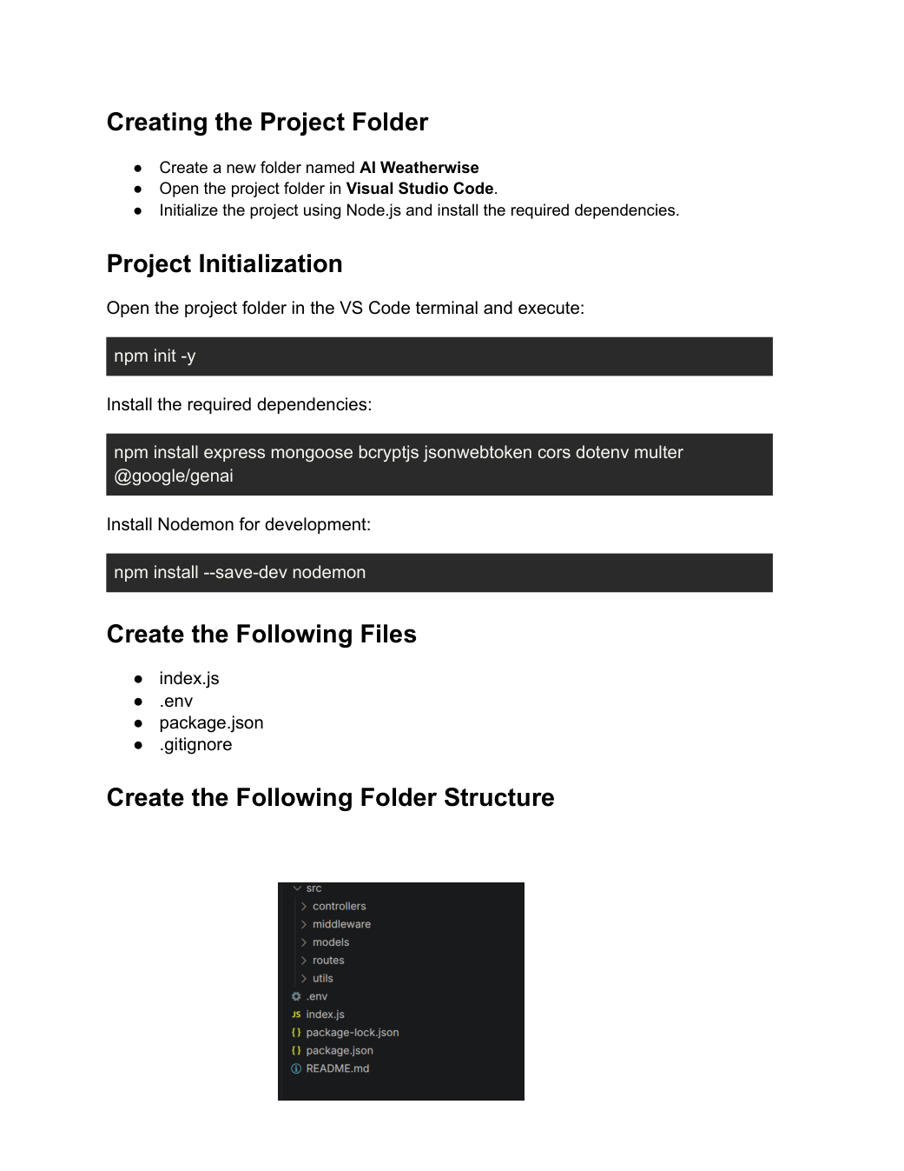

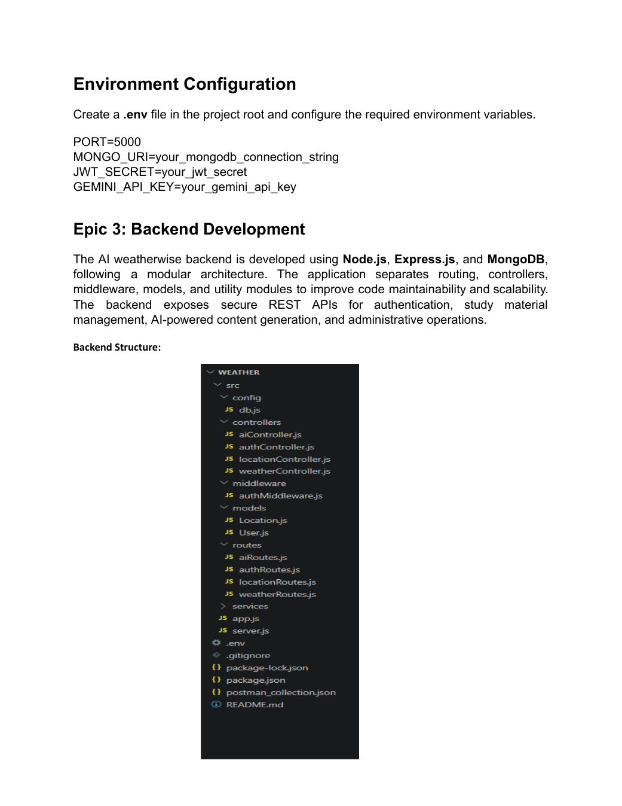

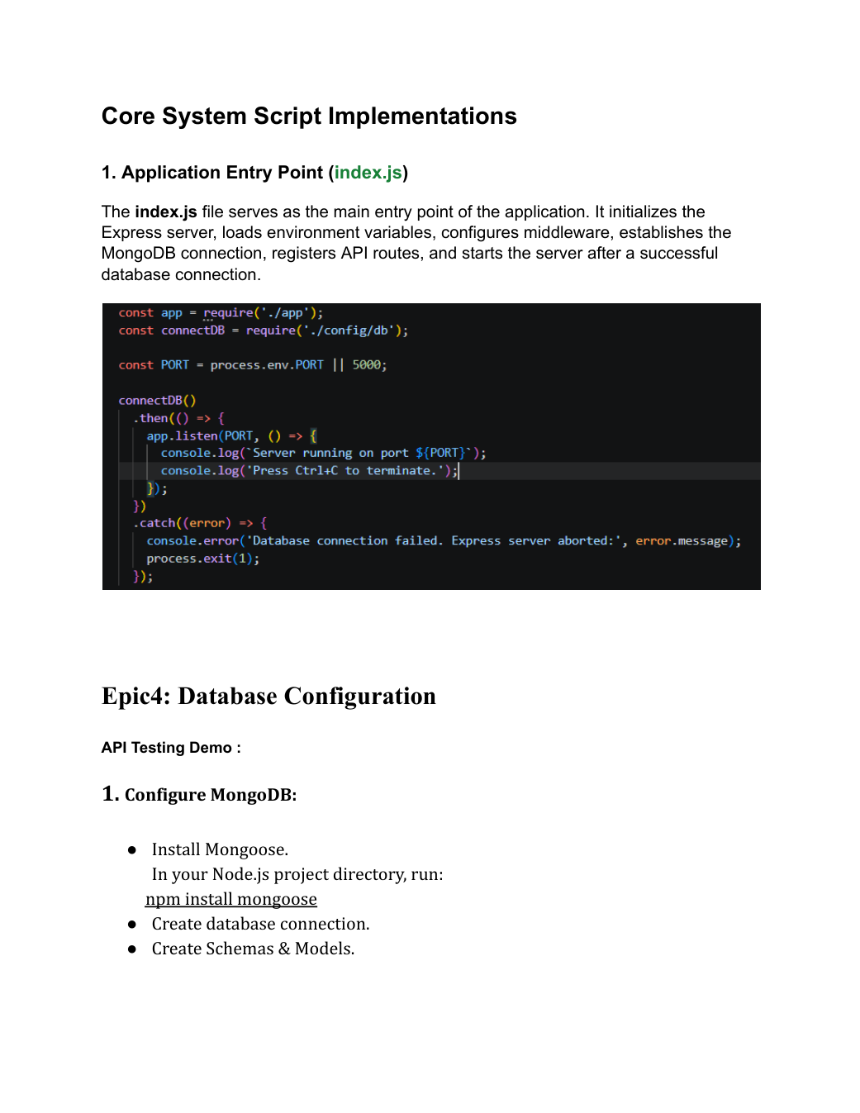

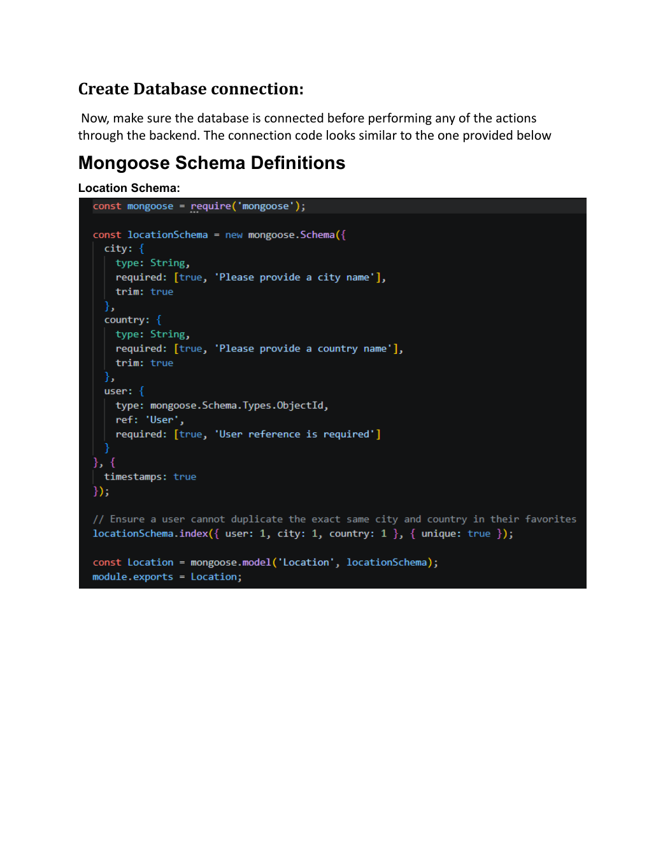

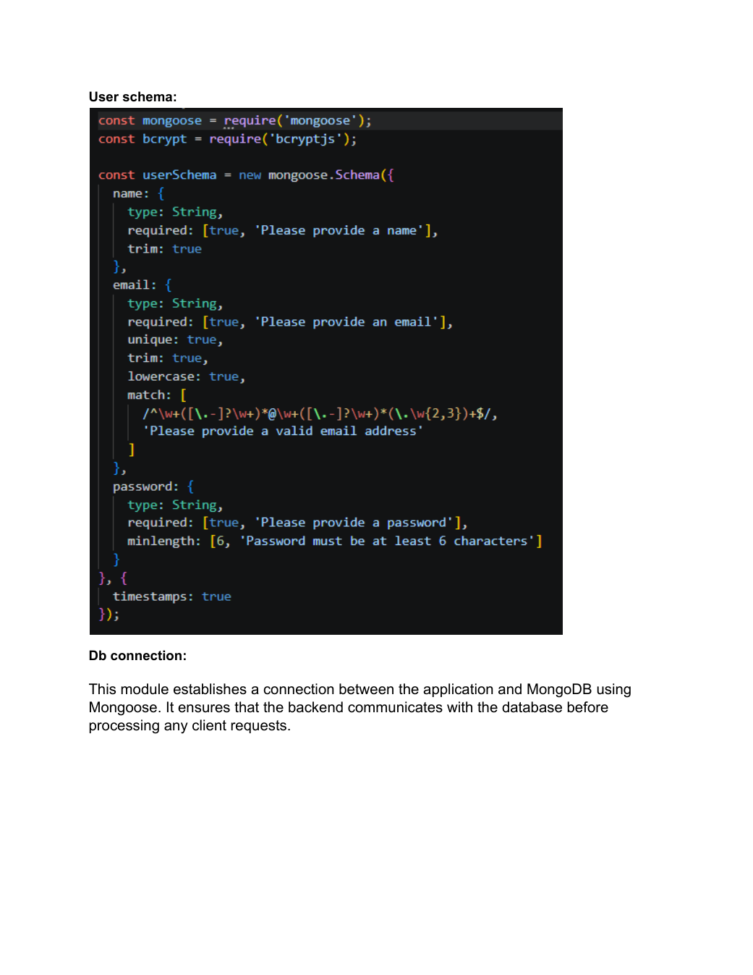

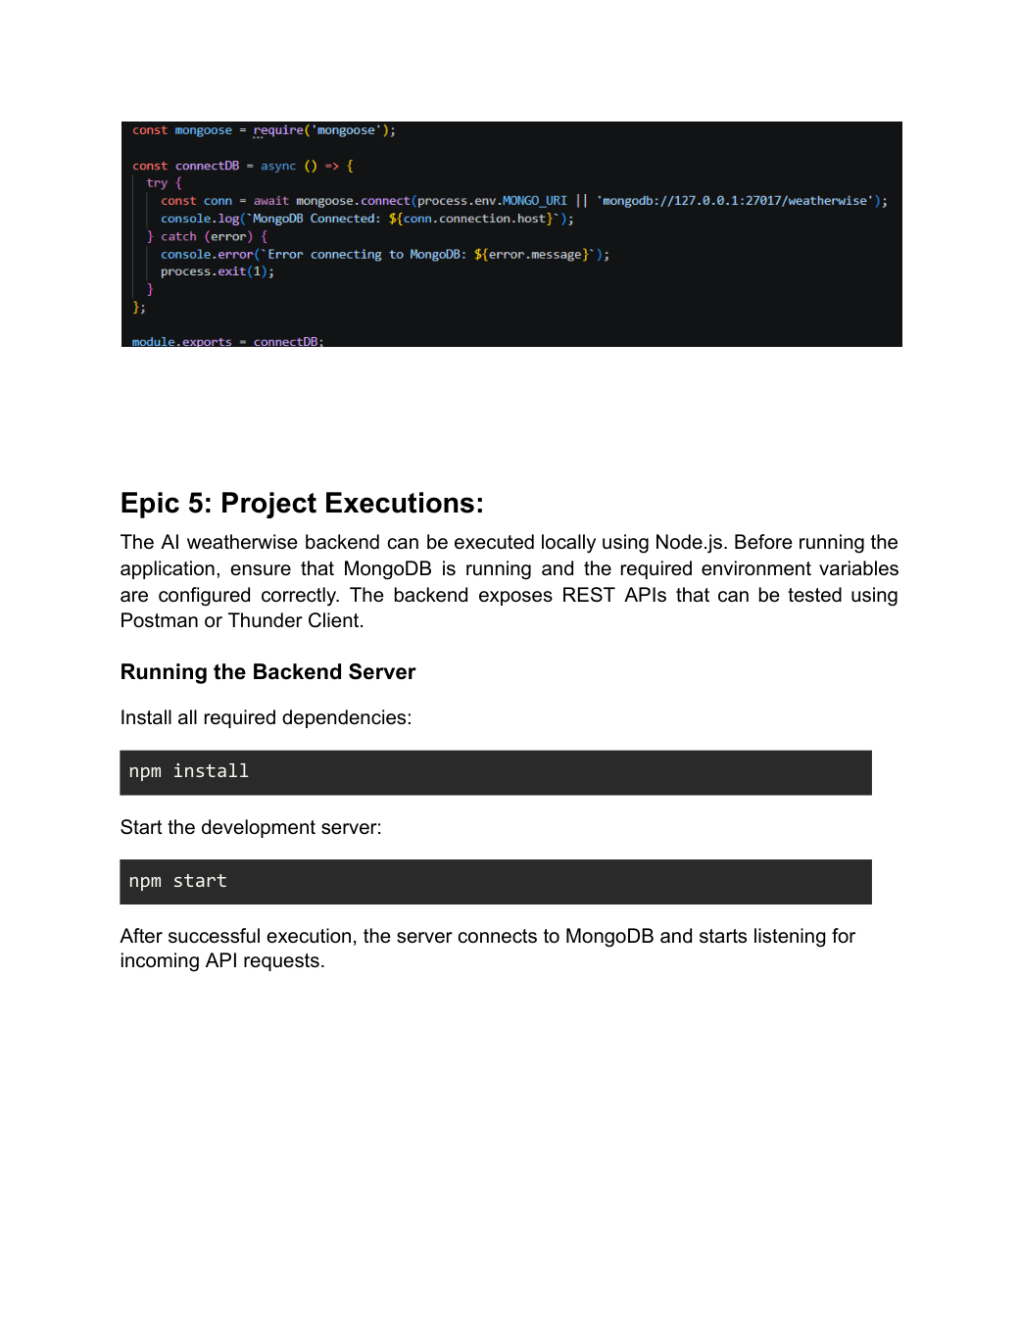

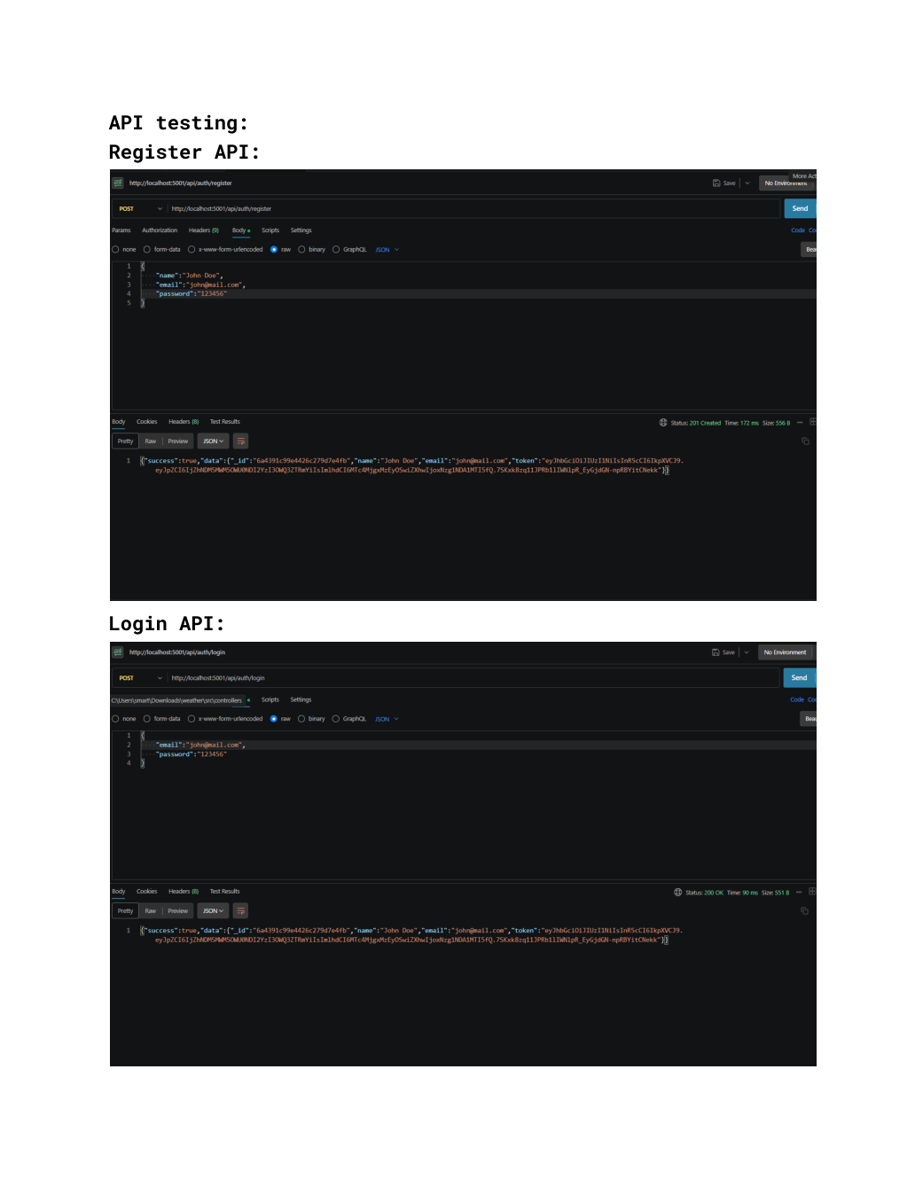

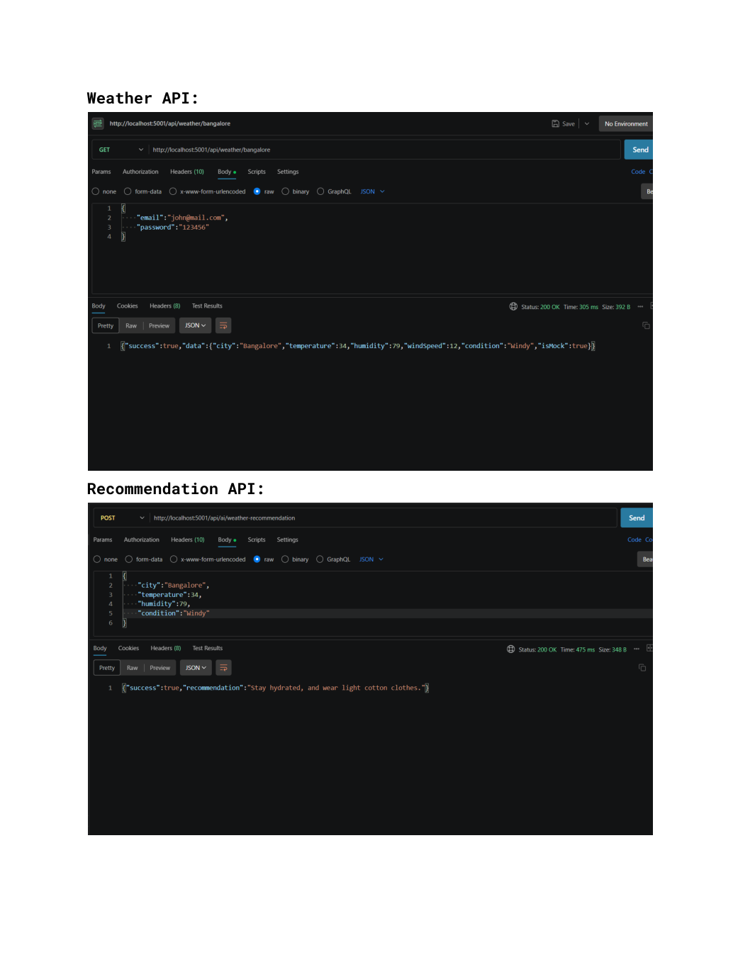

API TESTING VIDEO LINK: https://drive.google.com/file/d/1s22RKTg8SKs6ACc8QgPBSZzFYHongl0K/view?usp=drivesdk

DEMO VIDEO LINK: https://drive.google.com/file/d/1ji0o34D3ofx7OlNAjr-5oNaWWcIa-3hj/view?usp=drivesdk

CODE DRIVE: https://drive.google.com/drive/folders/1-gVTCUGpsRYn7BQflWIiEkHvJqor6A64?usp=sharing

GITHUB: https://github.com/rakshithavemala91-design/AI-WeatherWise.git

